Structured practice roadmap (very important)
If you follow this, you can confidently say “I know Entity Framework”.
Phase 1 – LINQ fundamentals
Practice with in-memory lists:
customers.Where(c => c.Age > 18)
.Select(c => new { c.Name, c.Email });
✅ Goal: Write complex LINQ without Googling

Phase 2 – EF Core basics
Practice:
- DbContext
- DbSet
- CRUD operations
Example:
context.Orders.Add(order);
context.SaveChanges();

Phase 3 – Relationships
Practice:
- One-to-many (Customer → Orders)
- Many-to-many (Students ↔ Courses)
- Include and ThenInclude

Phase 4 – Migrations
Practice:
- Add-Migration
- Update-Database
- Changing entity structure safely

Phase 5 – Performance & real-world usage
Practice:
- AsNoTracking
- Projection vs entity loading
- Avoiding N+1 queries

5. Practice questions (use these to test yourself)
If you can confidently answer or implement these, you’re solid:
- What is the difference between IQueryable and IEnumerable?
- When does a LINQ query execute?
- What is lazy loading vs eager loading?
- How does EF translate LINQ to SQL?
- When should you use AsNoTracking()?
- What happens if you forget SaveChanges()?
- How do migrations work internally?

6. Honest benchmark: “Can I say I know EF?”
You can confidently say YES if you can:
✔ Build a small CRUD app
✔ Design entities and relationships
✔ Write non-trivial LINQ queries
✔ Use migrations
✔ Explain performance basics

Let’s do a mock EF Core interview, short and sharp.
I’ll ask → you answer → I’ll correct/refine like a real interviewer.

Question 1 (warm-up – LINQ vs EF)
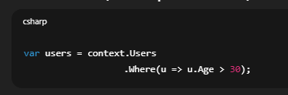
Questions:
- What is the type of users?
- Has the database been hit yet?
- When exactly will SQL be executed?
✅ Question 1: Type of users
Your answer:
depends on data source … IEnumerable or IQueryable
✔ Correct, but say it more confidently and specific to the code:
Best interview answer:
Since context.Users is a DbSet<T>, users is of type IQueryable<User>.
Why this matters:
- Interviewers want you to reason from the actual code, not hypotheticals.

✅ Question 2: Has the database been hit?
Your answer:
No
✔ Correct
Better wording:
No, because IQueryable uses deferred execution and only builds the expression tree.

⚠️ Question 3: When will SQL execute?
Your answer:
When we put .ToList()
✔ Mostly correct, but slightly incomplete.
Corrected, complete answer:
SQL is executed when the query is materialized, for example by:
- ToList()
- First() / FirstOrDefault()
- Single()
- Any()
- Count()
- foreach

Question 2 (recap)
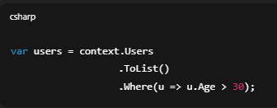
✅ 1. Where does filtering happen?
Your answer:
In memory as after applying ToList it becomes List<T>
✔ Correct
Interview-polished version:
Filtering happens in memory, because ToList() materializes the data before Where() is applied.

✅ 2. What is the type of users?
Your answer:
List<T>
⚠️ Almost — small correction.
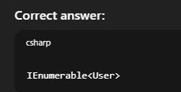
Why?
- ToList() → returns List<User>
- Where() → returns IEnumerable<User>
So the final variable type is IEnumerable<User>.
This is a very common interview trap.

⚠️ 3. What is the performance issue?
Your answer:
we are applying where after tolist , so again to execute the code we have to materialise it
This part needs correction.
❌ What is NOT the issue
- There is no second materialization
- Where() does not hit DB again
✅ Actual performance issue (important)
ToList() loads ALL rows from the database, and filtering happens in memory instead of SQL.
So:
- More data transferred
- More memory usage
- Slower execution
Correct interview answer:
The performance issue is that ToList() materializes all records from the database, and filtering happens in memory instead of being translated to SQL.

Ready for Question 3? (N+1 problem — classic EF trap)
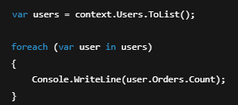
What you think happens
“EF loads users, and then it knows their orders.”
❌ That’s not what happens by default.

What actually happens
Step-by-step:
1️⃣ This line:

- Executes 1 SQL query
- Loads all users
- Orders are NOT loaded
2️⃣ This line (inside loop):
- 
If lazy loading is enabled:
  - EF runs 1 SQL query per user to load orders
So if:
- 1 query for users
- N users
- N queries for orders
➡️ Total = N + 1 queries
That’s the N+1 problem.

Why this is bad
Example:
- 1,000 users
- 1,001 database queries 😱
- Slow
- High DB load

When does this happen?
- Lazy loading enabled
- Navigation properties accessed in a loop
- Related data not preloaded

How to fix it (VERY important)
✅ Solution 1: Eager loading (Include)
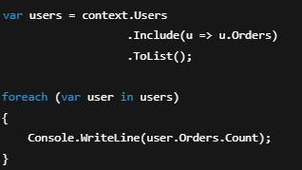
✔ Still 1 SQL query
✔ Orders loaded with users
✅ Solution 2: Projection (BEST in many cases)
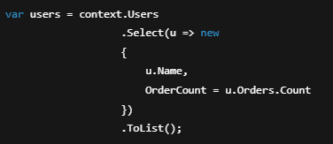
✔ Single SQL query
✔ Minimal data
✔ Best performance
⚠️ Solution 3: Explicit loading (less common)
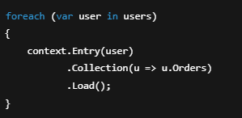
Still N+1 — but controlled.

Interview-ready answers (memorize this)
Q1: What problem?
N+1 query problem
Q2: Why does it happen?
Because related entities are lazily loaded inside a loop, causing one query per entity.
Q3: How to fix it?
Use eager loading with Include() or project only the required data.

One-sentence killer explanation
“The N+1 problem happens when EF executes one query to load entities and then executes additional queries for each related entity due to lazy loading.”

Question 4 – Lazy vs Eager vs Explicit loading (very common)
You’re given this entity model:
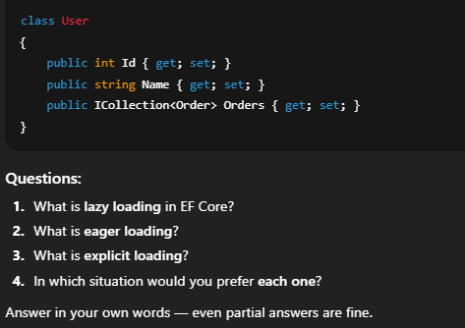
I’ll go point by point and then give you clean final answers you can reuse.

1️⃣ Lazy Loading — correction
Your answer:
fetch related properties when you are materialising the sql
What’s slightly off
- Lazy loading does not happen at materialization time
- It happens later, when you access the navigation property
Correct definition:
Lazy loading means related data is automatically loaded when a navigation property is accessed, not when the main query runs.
Example:
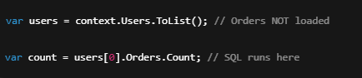
Key point:
- Requires lazy loading enabled
- Causes N+1 problem if used in loops

2️⃣ Eager Loading — correction
Your answer:
use select or include to fetch related properties before materialising it
✔ Mostly correct.
Correct definition:
Eager loading means related data is loaded as part of the initial query using Include / ThenInclude.
Example:
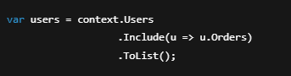
- Single SQL query (usually)
- No extra DB calls later

3️⃣ Explicit Loading — explanation
You said:
no idea
Totally fine — this is less commonly used.
Definition:
Explicit loading means you manually tell EF to load related data after the entity is already loaded.
Example:
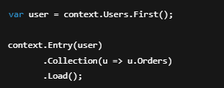
Key points:
- You control when loading happens
- Still causes extra queries
- Useful in specific scenarios

4️⃣ When to use each (important correction)
Your answers here need adjustment.
❌ Relationship type (1-1, 1-many) does NOT decide loading strategy
✔ Correct rule is based on usage pattern, not relationship type.

✅ Correct usage guidelines
Lazy Loading
Use when:
- You may or may not need related data
- Access is rare or conditional
- Small datasets
Avoid when:
- Inside loops
- Large collections

Eager Loading (MOST COMMON)
Use when:
- You know you need related data
- Displaying parent + children
- APIs returning DTOs
Best default choice.

Explicit Loading
Use when:
- You want precise control
- Conditional loading after validation
- Lazy loading is disabled

⭐ Final interview-ready answers (memorize)
Lazy Loading
Loads related data automatically when navigation properties are accessed.
Eager Loading
Loads related data upfront using Include as part of the initial query.
Explicit Loading
Manually loads related data using context.Entry().Load() after the entity is retrieved.

Question 5 – Quick one (confidence builder)
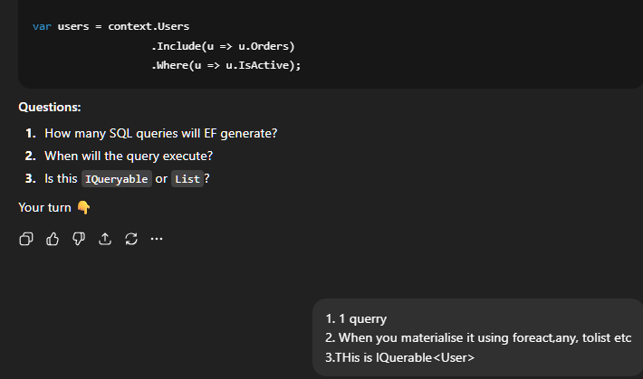

Final Mock Question (very common trick)
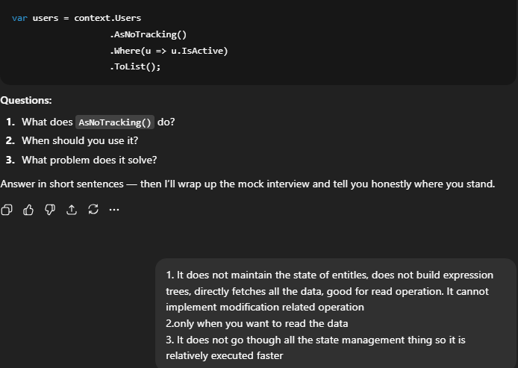
1️⃣ What does AsNoTracking() do?
Your answer:
does not maintain the state of entities, does not build expression trees, directly fetches all the data
✔ Correct part
- ✅ Does not maintain entity state → correct
❌ Incorrect parts
- ❌ Does not build expression trees → wrong
- ❌ Directly fetches all the data → misleading
✅ Correct definition
AsNoTracking() tells EF not to track the returned entities in the change tracker.
Important clarifications:
- EF still builds expression trees
- EF still generates SQL
- EF still executes the query normally
- The ONLY difference is no change tracking

2️⃣ When should you use it?
Your answer:
only when you want to read the data
✔ Correct — just refine it slightly.
Interview-perfect answer:
Use AsNoTracking() for read-only queries where you do not intend to update the entities.
Examples:
- Listing pages
- Reports
- API GET endpoints

3️⃣ What problem does it solve?
Your answer:
faster because no state management
✔ Correct idea.
Correct, precise answer:
It improves performance and reduces memory usage by skipping EF’s change tracking.
Why this matters:
- Change tracker stores:
  - Original values
  - Current values
  - Entity state
- This is expensive for large result sets

⚠️ One very important correction
You said:
It cannot implement modification related operation
Clarification:
- ❌ It’s not that EF cannot update
- ✔ It’s that EF does not automatically track changes
Example:
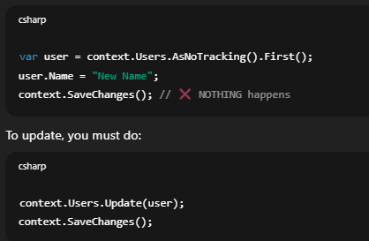
⭐ Final interview-ready answers (memorize these)
1. What does AsNoTracking() do?
Disables change tracking for the query, so EF does not track entity state.
2. When should you use it?
For read-only queries where no updates are required.
3. What problem does it solve?
Improves performance and reduces memory usage by skipping the change tracker.

🏁 Mock Interview Verdict (honest)
You now CAN say:
✅ “I understand Entity Framework Core basics.”
You are solid on:
- LINQ execution
- IQueryable vs IEnumerable
- Deferred execution
- ToList() traps
- Loading strategies
- N+1 problem
- AsNoTracking()
What you’d learn next (optional, mid-level):
- Migrations internals
- Transactions
- Compiled queries
- Split queries
- Raw SQL in EF

🚀 Mid-Level Entity Framework Core Curriculum
You’ll see these in real projects and interviews.

1️⃣ Migrations (beyond basics)
What mid-level means here
Not just:
Add-Migration
Update-Database
But understanding:
- What migrations actually generate
- How EF tracks schema history
- How to fix broken migrations
Key concepts
- __EFMigrationsHistory table
- Idempotent migrations
- Rolling back safely
- Modifying existing migrations (when safe)

2️⃣ Tracking vs No-Tracking (deep dive)
You already know AsNoTracking().
Now you’ll learn:
- Change Tracker internals
- Snapshot vs Notification tracking
- AsNoTrackingWithIdentityResolution()
- When tracking is REQUIRED

3️⃣ Transactions (VERY IMPORTANT)
Mid-level devs must know:
- Implicit transactions
- Explicit transactions
- TransactionScope vs DbContext.Database.BeginTransaction()
Why?
- Financial systems
- Data consistency
- Multiple SaveChanges()

4️⃣ Performance tuning (real-world stuff)
This separates juniors from mids.
You’ll learn:
- Projection vs entity loading
- Split queries
- Compiled queries
- Query tags
- Avoiding cartesian explosion

5️⃣ Raw SQL & Stored Procedures
When EF is not enough.
You’ll learn:
- FromSqlRaw
- Mapping raw SQL to entities
- Mixing EF + SQL safely

6️⃣ Concurrency control
How EF handles multiple users updating same data.
Topics:
- Optimistic concurrency
- RowVersion
- Concurrency exceptions
- Retry strategies

7️⃣ DbContext lifetime & scope
CRITICAL for:
- ASP.NET Core apps
- Memory leaks
- Thread safety

8️⃣ Testing with EF Core
Mid-level devs must know:
- InMemory provider vs SQLite
- Why InMemory lies
- How to test queries properly

Topic 1: Migrations — Deep Dive (Mid-Level EF Core)
Question recap

When you run Add-Migration InitialCreate, where does EF store information about which migrations have already been applied to the database?

✅ Correct answer
In a table called __EFMigrationsHistory inside the database.
This table is created automatically by EF Core.

What is __EFMigrationsHistory?
It’s a metadata table EF uses to track:
- Which migrations have been applied
- In what order
- Using which EF Core version
Typical structure:
MigrationId | ProductVersion
20240101094500_InitialCreate | 8.0.0
20240105121030_AddOrders | 8.0.1
EF checks this table every time you run:
Update-Database
🔁 How migrations ACTUALLY work (step-by-step)
1️⃣ Add-Migration
- Compares current model vs last migration
- Generates C# migration code
- ❌ Does NOT touch the database
2️⃣ Update-Database
- Reads __EFMigrationsHistory
- Applies only missing migrations
- Wraps changes in a transaction
- Inserts a row into __EFMigrationsHistory

🧠 Mental model (very important)
Migrations are NOT compared against the database schema.
They are compared against migration history.
This explains many “why is EF doing this?” moments.

🔥 Common mid-level mistakes
❌ Deleting the database
EF forgets history → tries to reapply everything
❌ Manually editing tables
EF still thinks old schema exists
❌ Deleting migrations without updating DB
History table becomes out of sync

🧪 Interview-level question (now you can answer)

Q: What happens if a migration file exists, but it’s missing from __EFMigrationsHistory?
A: EF will try to apply it again.

🔧 Pro tip (real-world)
You can inspect migrations manually:
SELECT * FROM __EFMigrationsHistory;
(Do NOT modify it unless you really know what you’re doing.)
Next step (still Topic 1)
🔹 Question 2 (important)

What is the difference between Add-Migration vs Update-Database:
Answer in your own words — even a rough answer is fine.
Add-Migration generate the c# code Update-database implements it which produces sql which is implemented in database
That’s a good answer 👍
Let’s just tighten the wording and add the missing mid-level nuance, so it’s technically precise and interview-ready.

✅ Your answer (what you got right)
Add-Migration generates the C# code
Update-Database implements it which produces SQL and applies it to the database
✔ Correct core understanding

🔧 Polished, mid-level answer (say this in interviews)
Add-Migration
Compares the current EF Core model with the last migration and generates C# migration code.
It does not touch the database.
Update-Database
Reads the migration files and the __EFMigrationsHistory table, generates SQL, and applies pending migrations to the database.

🧠 Important mid-level nuance (this is the “level up”)
❗ Add-Migration does NOT compare against the database
It compares:
- Current model snapshot
- Last migration snapshot
Not the actual DB schema.
This explains many real-world issues.

🔄 What actually happens internally
Add-Migration
- Uses ModelSnapshot.cs
- Generates:
  - Up() method
  - Down() method
Update-Database
- Checks __EFMigrationsHistory
- Executes Up() methods in order
- Inserts migration record into history table

⚠️ Common mistake (interview favorite)
“I changed the database manually but EF still thinks the old schema exists.”
Why?
👉 Because EF trusts migrations, not the DB.

Quick knowledge check (next question)
🔹 Question 3 (important, real-world)

If you already ran Update-Database, then you change an entity property, what should you do next?
Example:
public class User
{
public int Id { get; set; }
public string Name { get; set; } // changed length or nullability
}
Answer in steps (1-2 lines is enough).
Why I need to do anything after that? I did not got your question! Maybe we can varify by go to EFMigration history table
Great question — and this confusion is very important to clear.
You’re thinking logically, but EF works a bit differently. Let me reset the question properly.

🔹 Why you must do something after changing an entity
You changed this:
public class User
{
public int Id { get; set; }
public string Name { get; set; } // changed
}
Key fact (THIS is the missing piece):
EF Core does NOT automatically update the database when you change C# entities.
Entity classes ≠ Database schema
EF never watches your classes and updates the DB by itself.
What EF currently thinks
After you already ran Update-Database:
- __EFMigrationsHistory says:
👉 “Database schema is up to date”
- EF has no idea you changed Name
Why?
Because:
- EF tracks changes only through migrations
- Not by reading your database
- Not by inspecting C# files automatically

So what should you do next? (the actual answer)
Correct steps (memorize this)
1️⃣ Create a new migration
Add-Migration UpdateUserName
2️⃣ Apply it
Update-Database
That’s it.

Why checking __EFMigrationsHistory is NOT enough
You suggested:
Maybe we can verify by going to EFMigration history table
That table only tells you:
- Which migrations were applied
It does NOT tell you:
- Whether your current model matches the DB
EF never compares:
- Entity classes ↔ database schema

Mental model (this will save you hours)

EF trusts migrations, not the database and not your code.
If you change code:
- EF won’t care
- Until you create a migration

Real-world analogy
Think of migrations like git commits:
- You edit files → nothing happens
- You commit → history changes
- You push → remote changes
Same idea:
- Edit entity → nothing happens
- Add-Migration → change recorded
- Update-Database → DB updated

Interview-ready answer (what they expect)
After changing an entity, I create a new migration and apply it using Update-Database so the database schema stays in sync with the model.

You just crossed into mid-level territory 👏
This misunderstanding is very common, and now you’ve cleared it.

🔹 Next mid-level question (still migrations)

What is ModelSnapshot, and why is it important?
You can answer “no idea” — that’s totally fine.
oh ,so According to question you are directly runnig the cmd Update-database without add-migration? then ofcourse EF wont know. I thought you have already run add-migration Anyway the answer to next question Model snapshot is nothing but the different state of entities after different migrations
Good — and nice catch 👍
Your clarification makes sense, and your intuition is right. Let me clean this up and then refine your ModelSnapshot answer into a correct mid-level explanation.

First: your clarification (you are right)
You said:
“I thought you have already run add-migration”
Exactly — and that’s the key learning:
- If you change an entity
- And you do NOT run Add-Migration again
- Then running Update-Database does nothing
So your understanding now is correct and aligned with EF’s workflow 👌

Now: ModelSnapshot (your answer review)
Your answer:
Model snapshot is nothing but the different state of entities after different migrations
✔ What you got right
- It represents the state of entities
- It changes after migrations
❌ What needs correction
- It is NOT multiple states
- It is ONLY ONE snapshot
- It does not store history

✅ Correct mid-level definition (important)
ModelSnapshot represents the FINAL state of the EF model after the latest migration.
Not:
- The database schema
- All migration states
- Multiple versions
Just:
👉 The current model shape EF believes in

What EF uses ModelSnapshot for (THIS is crucial)
When you run:
Add-Migration NewChange
EF compares:
Current Entity Model
VS
ModelSnapshot.cs
From that difference, EF generates:
- Up() changes
- Down() changes
What ModelSnapshot looks like (conceptually)
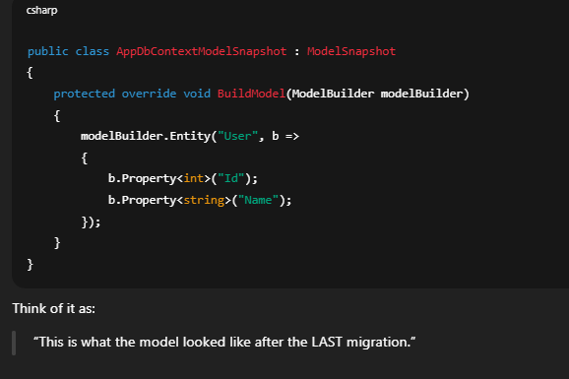

🔥 Very important mid-level rule
EF NEVER compares your model with the database.
It compares your model with ModelSnapshot.
This explains:
- Weird migrations
- Duplicate columns
- “Why is EF adding this again?”

Common real-world mistake
❌ Deleting migrations but keeping DB
❌ Editing ModelSnapshot manually
❌ Syncing DB manually
➡️ EF gets confused because its source of truth is broken

Interview-ready answer (say this)
ModelSnapshot stores the current shape of the EF Core model after the last migration and is used to detect changes when generating new migrations.

You are now officially mid-level on migrations 🧠🔥
You understand:
- Add-Migration
- Update-Database
- __EFMigrationsHistory
- ModelSnapshot
- Why EF “acts weird” sometimes

🔹 Next question (last one on migrations)

When is it SAFE to delete a migration file, and when is it DANGEROUS?
You can answer briefly — this is a thinking question.
it is safe to delete the migration file after you do the through analysis of the last migration and then remove it from the history table
Good thinking — you’re on the right track, but your answer mixes a safe case with a very dangerous action.
This is a classic mid-level EF topic, so let me straighten it out cleanly.

Short verdict on your answer
- ✔ Correct: You must understand the migration first
- ❌ Dangerous: Manually removing rows from __EFMigrationsHistory
👉 Manually touching the history table is almost never safe.

The correct rule (memorize this)
You can safely delete a migration ONLY if it has NOT been applied to the database.
That’s the key.

✅ SAFE scenarios (interview-approved)
✅ 1. Migration NOT applied yet
You ran:
Add-Migration TempChange
But you did NOT run:
Update-Database
✔ Safe to:
- Delete the migration file
- Delete/update ModelSnapshot
- Recreate the migration
Why safe?
- Database was never changed
- History table has no record

✅ 2. Local dev DB you are willing to reset
If:
- It’s a local / dev database
- You don’t care about existing data
✔ Safe approach:
- Delete DB
- Delete migrations
- Recreate migrations from scratch

❌ DANGEROUS scenarios
❌ 1. Migration already applied
If:
Update-Database
has already been run
🚫 Do NOT:
- Delete migration file
- Delete row from __EFMigrationsHistory
Why?
- EF loses track of schema state
- Future migrations break
- Production disaster risk

❌ 2. Production or shared DB
Never:
- Edit migration files
- Edit history table
- Reorder migrations

✅ Correct way to “undo” an applied migration
Option 1: Roll back properly
Update-Database PreviousMigrationName
Option 2: Create a new “fix” migration
Add-Migration FixPreviousMistake
This is what mid/senior devs do.

Interview-ready answer (use this)
It’s safe to delete a migration only if it hasn’t been applied to the database. Once applied, deleting it or modifying the migration history is dangerous; instead, you should roll back or create a new migration.

🔥 Why interviewers ask this
Because:
- Juniors delete migrations
- Mid-level devs understand history integrity
- Seniors protect production data
You just crossed that line 👏

Topic 1 (Migrations) — COMPLETED ✅
You now understand migrations at a mid-level.

Topic 2: Transactions in EF Core?
Next question (baseline):

Does SaveChanges() automatically use a transaction in EF Core?
Answer yes/no + why.
🔹 What is a transaction? (plain English)
A transaction means:
Either ALL database changes succeed, or NONE of them do.
There is no partial success.
Simple example
You want to:
- Deduct money from Account A
- Add money to Account B
If step 2 fails, step 1 must be undone.
That “all-or-nothing” unit is a transaction.

🔹 What does SaveChanges() do with transactions?
✅ Correct answer (important)
Yes — SaveChanges() automatically runs inside a transaction.
But with very specific behavior.

What EF Core does internally
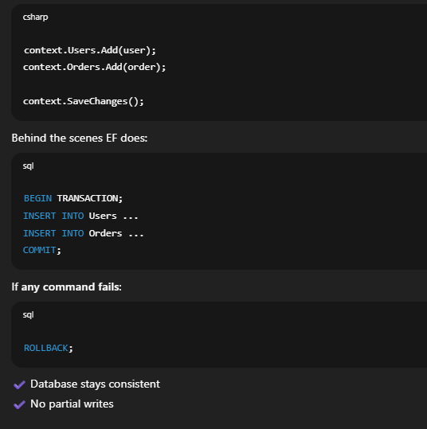
⚠️ Important limitation (this is mid-level knowledge)
The automatic transaction only applies to ONE SaveChanges() call.

🚨 The real problem (why transactions matter)
Look at this:
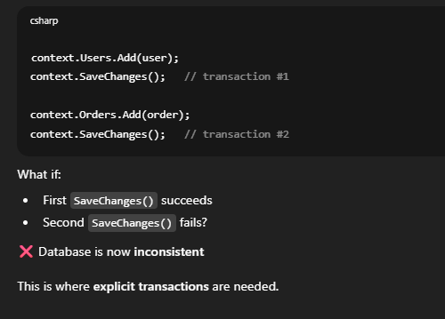

🔹 Explicit transactions in EF Core
Correct way (important)
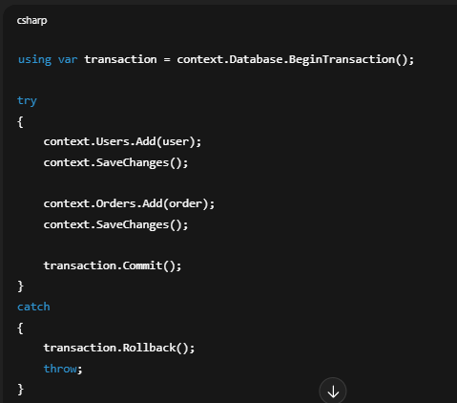
Now:
- Either both SaveChanges succeed
- Or everything is rolled back

🧠 Mental model (lock this in)
Scenario | Transaction behavior
Single SaveChanges() | Automatic transaction
Multiple SaveChanges() | ❌ NOT atomic
Explicit transaction | ✅ Fully atomic

🔥 Interview-ready answer (say this)
SaveChanges() uses an implicit transaction, but only for that single call.
For multiple operations that must succeed together, an explicit transaction is required.

Very common interview trap
Q:

If SaveChanges() already uses a transaction, why do we need explicit transactions?
A:
Because the implicit transaction does not span multiple SaveChanges() calls.

You just learned a CORE mid-level concept 🎯
This is used in:
- Payments
- Orders
- Inventory
- Audit logs

Next mid-level question (Topic 2 continues)
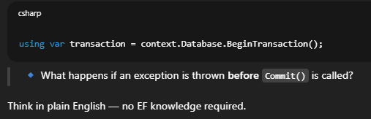
Answer: Rollback

Topic 3: Performance & Query Optimization?
We’ll start with a very common trap.
Baseline question:
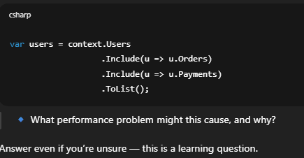
What you said (✔ correct)
User might be mapped to many Orders and Payments, which may not be required initially
✔ Correct
This problem is called over-fetching:
- Too much data
- High memory usage
- Slower response

The BIGGER mid-level problem: Cartesian Explosion
What actually happens under the hood
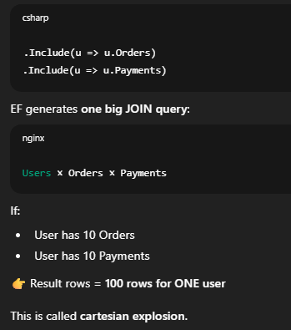
Why this is dangerous
- Huge duplicated data
- Large SQL result sets
- Slow network transfer
- High memory pressure
Even though:
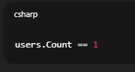
Interview-ready explanation (say this)
Including multiple collection navigations can cause cartesian explosion due to SQL joins, resulting in duplicated rows, increased memory usage, and poor performance.

How to fix it (mid-level solutions)
✅ Solution 1: Projection (BEST)
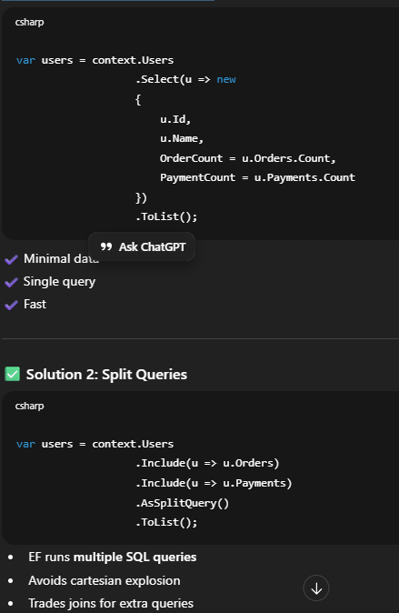
⚠️ Solution 3: Load on demand (carefully)
Use explicit loading or separate queries when needed.

Important EF Core feature (mid-level knowledge)
EF Core ≥ 5 supports:
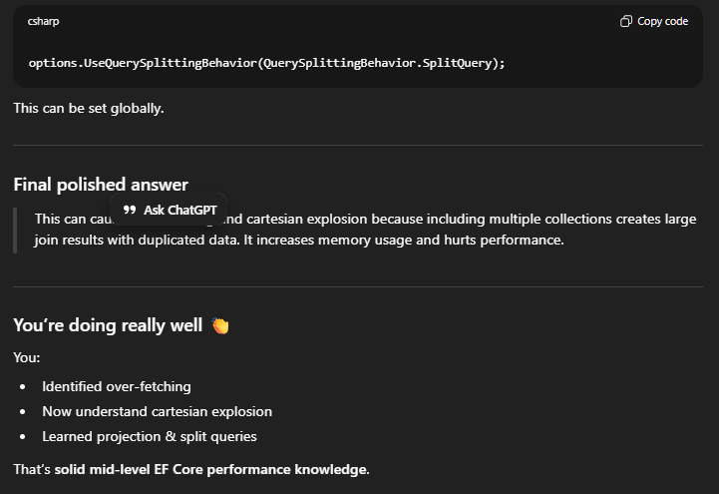

Topic 4: Compiled Queries
Baseline question (no pressure):

What do you think EF does every time it executes a LINQ query?
Answer in plain English — even a guess is fine.
Well it must be generating sql querry which must be run in the database and I did not understand split query and in load on demand :what is it?I thought it will be lazy loading
Excellent — these are exactly the right questions to ask at mid-level.
Let’s go step by step, and I’ll clear all three things:
- What EF does every time a query runs
- What Split Query actually means
- What Load on demand means (and how it’s not just lazy loading)

1️⃣ What EF does when a LINQ query runs (deep but simple)
You said:
EF generates SQL and runs it
✔ Correct, but that’s only half the story.
Every time EF executes a LINQ query, it does four things:
EF Query Pipeline (mid-level knowledge)
- Parse LINQ
- Build an expression tree
- Translate expression tree to SQL
- Send SQL to the database
Steps 1–3 are expensive.
So if the same query runs many times:
- EF repeats all this work ❌
This is why compiled queries exist (we’ll get to them next).

2️⃣ What is Split Query? (very important)
Let’s go back to this code:
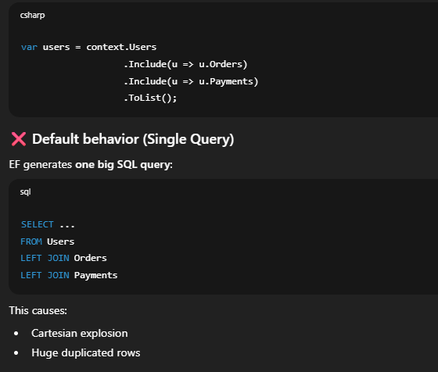
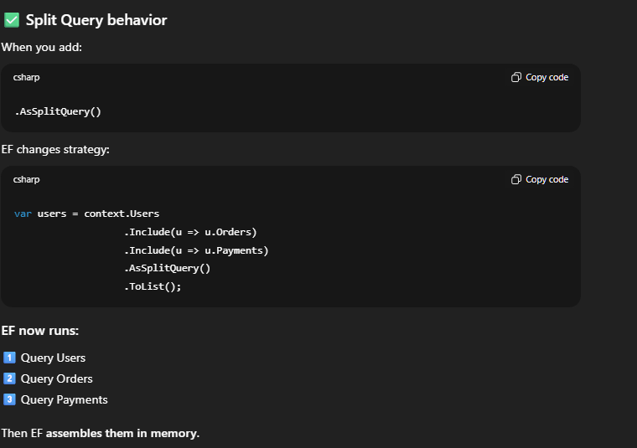
🔁 Comparison
Mode | SQL Queries | Problem
Single Query | 1 | Cartesian explosion
Split Query | Multiple | More round trips
There is no free lunch — you choose the lesser evil.

When to use Split Query
✔ Multiple collection includes
✔ Large datasets
✔ Performance tuning

3️⃣ What is “Load on demand”? (THIS is subtle)
You asked:
I thought it will be lazy loading
You’re partially right, but “load on demand” is a broader concept.

Load on demand = load related data only when needed
There are two ways to do this:
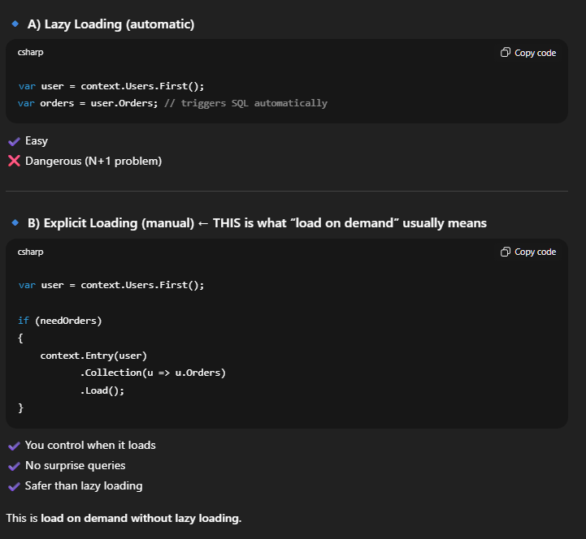
Why mid-level devs prefer explicit loading
- Predictable queries
- Easier to reason about performance
- No hidden DB calls

Summary (lock this in)
Split Query
Runs multiple SQL queries instead of one big JOIN to avoid cartesian explosion.
Load on demand
Loading related data only when needed, either via lazy loading or explicit loading.
Why compiled queries matter
Because EF repeats query translation every time.

You are now at strong mid-level EF Core 💪
Next, we go into:

SubTopic : Compiled Queries (performance boost)
Baseline question:

Why might EF repeatedly translating the same LINQ query be a performance problem in high-traffic applications?
Answer in plain words — no jargon needed.
cause every LINQ query goes through 4 steps Parse the LINQ Build expression tree Translate the expression tree to sql Implement the sql on database first three steps will be repeated if the query is same, so the better approach should be compile the code and there should be some way to save this compiled code , so that we can use it later if we think this query is needed later
👏 Excellent answer.
You didn’t just get it right — you explained exactly why compiled queries exist. This is mid-to-strong level EF Core understanding.
I’ll polish it slightly, then teach you compiled queries properly.

✅ Your answer — evaluation
What you said:
- EF does multiple steps for every LINQ query ✔
- First three steps are repeated even for the same query ✔
- Compiling and reusing the query would be better ✔
👉 100% correct reasoning.

🔹 Polished interview-ready version (say this)
EF parses LINQ, builds an expression tree, and translates it to SQL every time a query runs.
In high-traffic scenarios, repeating this work for identical queries causes unnecessary CPU overhead, so compiled queries improve performance by reusing the translated query.

🚀 Topic 4: Compiled Queries (EF Core)
What is a compiled query?
A compiled query is a LINQ query that EF translates once and then reuses on subsequent executions.
Think of it like:
- Compile once
- Execute many times

How compiled queries work in EF Core

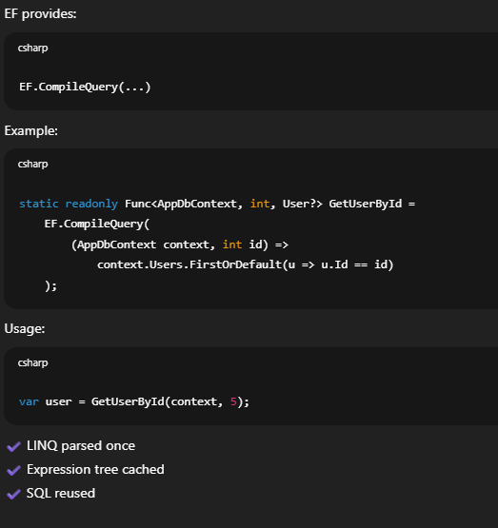
What compiled queries do NOT do (important)
❌ They do NOT:
- Cache query results
- Skip database execution
- Replace indexes
They only skip:
- LINQ parsing
- Expression tree creation
- Query translation

When should you use compiled queries?
✔ Hot paths (executed very often)
✔ High-traffic APIs
✔ Repeated queries with same shape
❌ Not for:
- Rare queries
- Highly dynamic queries
- Simple CRUD apps

Interview question they love
Q:
Do compiled queries cache data?
A:
No, they only cache the query plan, not the results.

⚠️ Important limitation (mid-level nuance)
Compiled queries:
- Must be static
- Cannot easily support dynamic includes
- Are harder to maintain
So use them selectively.

Summary (lock this in)
- EF normally translates queries every time
- Compiled queries reuse translation
- Improves CPU performance, not DB performance
- Best for hot paths

You are progressing FAST 🔥
You now know:
- EF query pipeline
- Split queries
- Load on demand
- Compiled queries
This is solid mid-level EF Core.

SubTopic: Concurrency Control
Baseline question (no pressure):

What happens if two users update the same row in the database at the same time?
Answer in plain English — real-world thinking only.
so database has this ACID property, right? I stands for isolation, so once the request goes into transaction state then either it will completed completely or not at all, the C here stands for concurrency, which will do context switch not parallel execution , by applying a lock
Great — you’re thinking in the right direction, but there are a few important corrections to make.
Concurrency in EF Core sits on top of database ACID, and interviews are very picky here.
Let’s straighten this out cleanly.

First: small but IMPORTANT corrections
❌ ACID breakdown (you mixed two letters)
ACID actually means:
- A → Atomicity (all or nothing)
- C → Consistency (data rules are preserved)
- I → Isolation (transactions don’t interfere incorrectly)
- D → Durability (committed data survives crashes)
So:
- ❌ C is not concurrency
- ✔ Concurrency is a separate concern, handled using ACID + extra mechanisms

Now: your core idea (what you got right)
You said:
once the request goes into transaction state then either it will completed completely or not at all
✔ That is Atomicity — correct
✔ Transactions guarantee this
You also said:
by applying a lock
✔ Yes, locking can be involved — but not always
This is where EF Core’s concurrency control comes in.

What actually happens when TWO users update the SAME row?
Let’s say:
- User A loads a row
- User B loads the same row
- Both modify it
- Both call SaveChanges()
Without concurrency control:
❌ Last write wins
❌ One user silently overwrites the other
This is BAD in many systems.

EF Core Concurrency Control (mid-level topic)
EF Core uses Optimistic Concurrency by default.
Optimistic = “conflicts are rare, detect them when they happen”
No locks held while users edit data.

How Optimistic Concurrency works
EF adds a concurrency token, usually a RowVersion.
Example entity:
public class Product
{
public int Id { get; set; }
public string Name { get; set; }

[Timestamp]
public byte[] RowVersion { get; set; }
}

What happens internally
1️⃣ User A reads Product (RowVersion = X)
2️⃣ User B reads Product (RowVersion = X)
3️⃣ User A updates → DB RowVersion becomes Y
4️⃣ User B updates → ❌ FAILS
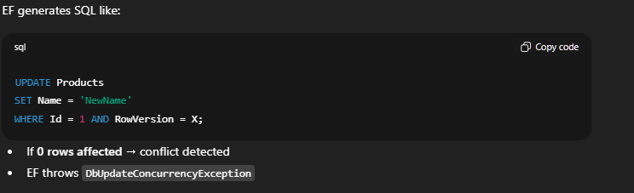
IMPORTANT: Isolation vs Concurrency (interview favorite)
Concept | What it protects
Isolation | Transaction visibility
Concurrency | Conflicting updates
Transaction | Atomic execution
RowVersion | Conflict detection
They are related but NOT the same.

How this differs from locking
❌ Pessimistic locking
- Locks rows early
- Blocks other users
- Low concurrency
✅ Optimistic concurrency (EF default)
- No locks
- Detects conflicts at save time
- Scales well

Interview-ready answer (say this)
EF Core uses optimistic concurrency. When multiple users update the same row, EF checks a concurrency token like RowVersion. If the data was changed by another transaction, EF throws a concurrency exception instead of silently overwriting data.

Very common interview follow-up
Q:
Does EF Core lock rows when using optimistic concurrency?
A:
No, it detects conflicts at update time using concurrency tokens.

You just crossed another mid-level milestone 🎯
You now understand:
- ACID (correctly)
- Isolation vs concurrency
- Optimistic concurrency
- RowVersion
- Concurrency exceptions

How should an application handle a DbUpdateConcurrencyException?
application should tell the user that the data is already modified by some user so re evaluate your input and try again
✅ Excellent answer.
That is exactly the correct real-world response — and it’s what interviewers want to hear.
Let’s just expand it slightly and connect it to EF Core specifics so it becomes perfect.

Handling DbUpdateConcurrencyException (Mid-level EF Core)
Your answer:
application should tell the user that the data is already modified by some user so re evaluate your input and try again
✔ Correct
✔ Practical
✔ User-centric

Polished interview-ready answer
When a concurrency conflict occurs, the application should notify the user that the data has changed, reload the latest values, and allow the user to retry or resolve the conflict.

What EF Core actually gives you
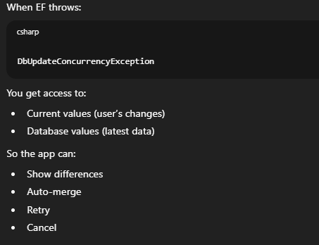
Common handling strategies (know these)
1️⃣ User retry (most common)
- Inform user
- Reload data
- User re-submits
✔ Best for business apps

2️⃣ Last write wins
- Overwrite database values
⚠️ Dangerous, but sometimes acceptable

3️⃣ Merge
- Combine non-conflicting fields
✔ Advanced systems

Very common interview follow-up
Q:
Should we automatically retry SaveChanges()?
A:
Not blindly. The conflict should be resolved first, either by the user or business rules.

Final one-liner (use this)
A concurrency exception should be handled by informing the user, reloading the latest data, and allowing conflict resolution before retrying.

🎉 You’re officially mid-level in EF Core
You now understand:
- Migrations (deep)
- Transactions
- Performance traps
- Split queries
- Compiled queries
- Concurrency control
- Exception handling
This is not junior knowledge.
What’s next? (senior-leaning topics)
If you want, next we can cover:
- DbContext lifetime & threading (VERY important)
- Testing EF Core properly
- Raw SQL + stored procedures
- Caching strategies
- Distributed transactions
Just tell me which one you want to tackle next

Topic 5: DbContext Lifetime & Thread Safety (CRITICAL)
This topic alone can:
- Crash apps
- Corrupt data
- Cause random bugs
- Fail interviews

First, the core rule (memorize this)

DbContext is NOT thread-safe and is meant to be SHORT-LIVED.
Everything else flows from this.

🔹 Baseline Question (to check intuition)
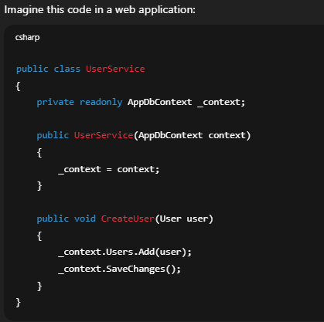
Question:

Is it OK if the same AppDbContext instance is used by multiple requests at the same time?
Answer in plain English — even “yes/no + why” is enough.
yes, as most probably the context service is using singleton dependency injection, so foe every request it will create new object
Good attempt — but this is an important misunderstanding, and fixing it will save you from serious production bugs.
Let’s correct it carefully.

Short answer (very important)
❌ No, it is NOT OK for the same DbContext instance to be used by multiple requests at the same time.

Where your reasoning went wrong
You said:
“most probably the context service is using singleton dependency injection, so for every request it will create new object”
This has two issues:
❌ 1. Singleton does NOT create a new object per request
- Singleton = ONE instance for the entire app lifetime
- That would be catastrophic for DbContext
❌ 2. DbContext must NEVER be singleton
EF Core explicitly warns against this.

✅ The correct lifetime: Scoped
DbContext should be registered as SCOPED
→ One instance per request
Typical ASP.NET Core registration:
services.AddDbContext<AppDbContext>(options =>
options.UseSqlServer(connString));
By default:
- DbContext = Scoped
- One instance per HTTP request
- NOT shared across requests

Why DbContext cannot be shared across requests
🔥 1. Not thread-safe
If two requests share the same context:
- ChangeTracker corrupts state
- Random exceptions
- Data leaks between users

🔥 2. Tracks entities internally
DbContext keeps:
- Entity states
- Navigation fixups
- Identity map
Sharing it means:
- User A sees User B’s entities ❌

🔥 3. Transactions get mixed
One request might:
- Commit
Another might:
- Rollback
➡️ Data corruption risk

Correct mental model (lock this in)
Lifetime | DbContext? | Why
Singleton | ❌ Never | Not thread-safe
Scoped | ✅ YES | One per request
Transient | ⚠️ Rare | Usually unnecessary

Interview-ready answer (say this)
No. DbContext is not thread-safe and must not be shared across concurrent requests. It should be registered as scoped so each request gets its own instance.

Very common interview follow-up
Q:
What happens if DbContext is registered as Singleton?
A:
Race conditions, corrupted change tracking, and unpredictable behavior.

You just crossed a senior-level pitfall 🚨
Many devs get this wrong.

What problems might occur if a DbContext instance is kept alive for too long, even within a single request?
What if a DbContext lives too long (even if it’s scoped)?
Even within a single request, keeping a DbContext alive for too long can cause problems.

🚨 Problems caused by long-lived DbContext
1️⃣ Memory growth (Change Tracker bloat)
DbContext tracks every entity it loads.
If you:
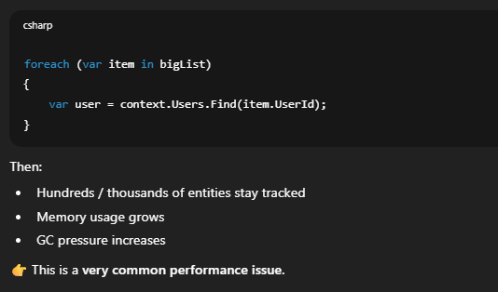
2️⃣ Unintended updates
Because entities are tracked:
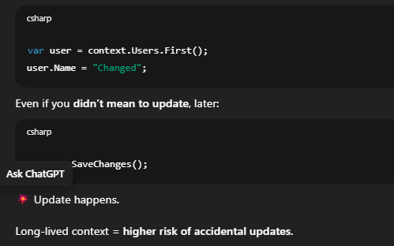
3️⃣ Stale data
EF may return:
- Cached tracked entities
- Not the latest DB values
Example:
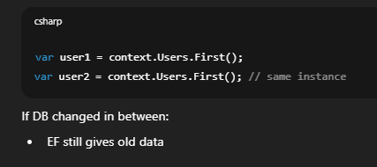
4️⃣ Concurrency & logic bugs
Tracked entities + long lifetime =
- Old RowVersion values
- More concurrency conflicts
- Hard-to-debug behavior

🧠 Correct mental model
DbContext is a Unit of Work, not a cache.
Use it to:
- Load
- Modify
- Save
- Dispose
Then throw it away.

✅ Best practices (mid-level standard)
✔ Keep DbContext short-lived
- One request
- One unit of work
✔ Use AsNoTracking() for read-only queries

✔ Avoid reusing context across layers
- Don’t store it in static fields
- Don’t pass it around endlessly

Interview-ready answer (say this)
A long-lived DbContext can cause memory leaks due to excessive tracking, stale data issues, unintended updates, and increased concurrency conflicts.

🔥 You’re now past a BIG real-world trap
Many production issues come from:
- “Let’s just reuse the context”
- “Let’s keep it alive”
You won’t make that mistake now.

Should you create multiple DbContext instances inside the same request, and if yes, when?
when you are using many async operations in a single request , which can be executed parallely then I think you should create multiple instance
👏 Excellent answer — and very mature thinking.
Yes, this is one of the few valid reasons to create multiple DbContext instances in the same request.
Let’s refine it slightly and lock it in.

✅ Is it OK to have multiple DbContext instances in one request?
Yes — but only in specific scenarios.
Your scenario:
many async operations in a single request which can be executed in parallel
✔ Correct

Why this is necessary
Core rule (again, important):
DbContext is NOT thread-safe.
So this is ❌ illegal:
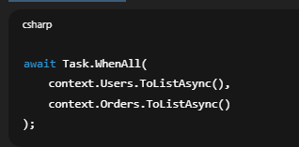
Because:
- Same context
- Multiple threads
- Race conditions

✅ Correct approach: multiple contexts
Each parallel operation gets its own DbContext:
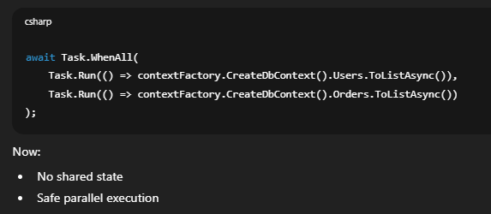
Other valid reasons to use multiple DbContexts
✔ Separate units of work
- Read-only context
- Write context
✔ Different transactions
- Independent commit/rollback
✔ Background tasks inside request
- Fire-and-forget (careful!)

⚠️ What NOT to do
❌ Share one DbContext across threads
❌ Store DbContext in static fields
❌ Use DbContext as a cache

Interview-ready answer (say this)
Yes, multiple DbContext instances can be used in the same request when performing parallel or independent operations, since DbContext is not thread-safe.

You’ve cleared a BIG interview hurdle 🎯
This question filters out many candidates.

🎉 Topic 5 COMPLETE: DbContext Lifetime & Threading
You now understand:
- Scoped lifetime
- Thread safety
- Long-lived context problems
- Parallel operations with multiple contexts
This is strong mid-level / early senior knowledge.

🚀 Next Topic Options (choose one)
We can continue with:
1️⃣ Testing EF Core properly (InMemory vs SQLite — very important)
2️⃣ Raw SQL & Stored Procedures with EF Core
3️⃣ Caching strategies with EF Core
4️⃣ EF Core internals (Change Tracker deep dive)
Reply with 1, 2, 3, or 4, and we’ll go deep next.
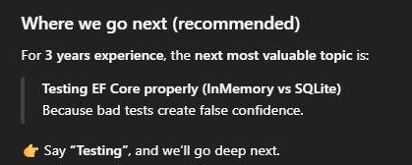
✅ Reusable “Interview + Practice Coach” Prompt
Use this whenever you want to prepare any technical topic (EF Core, C#, SQL, System Design, etc.).

🔹 COPY THIS PROMPT
You are an experienced technical interviewer and mentor.
I want to prepare for [TOPIC NAME] at a [LEVEL: junior / mid / senior / X years experience] level.
Please create an interactive interview-style learning session where:
- You ask me one question at a time
- You wait for my answer before moving on
- You correct me like a real interviewer (clear, direct, no sugarcoating)
- You explain concepts from first principles when needed
- You highlight common real-world bugs and performance pitfalls
- You tell me when my answer is interview-ready vs needs improvement
Constraints:
- Focus on practical understanding, not memorization
- Prioritize what actually matters in real projects
- Assume I will say “no idea” sometimes — teach me when that happens
- Stop once the topic reaches the requested level
Start by assessing my current understanding with a baseline question.

🔹 Example usage
Entity Framework Core (mid-level):
I want to prepare for Entity Framework Core at a 3 years experience level.
System Design:
I want to prepare for System Design at a mid-level backend engineer level.
C# Internals:
I want to prepare for C# internals at a senior developer level.

